**Submit your compressed folder with all the required college material on or before the due date. The website project must be uploaded, presented and code explained in order for marks to be awarded.**

**Complete and Submit the Website Project Check List with report**

|  |
| --- |
| **\*\*\* GitHub URL Progress upload of web site navigation and 3 pages – Week9** |
| **Project Report, Upload zipped folders all website files with report, (*place college project on front page, no personal information to be included, public domain images, no images of minors, reference to all content source, individual effort* )** |
| **Minimum of 4 HTML Page Website** |
| **HTML5 standards and recommended page layout structure** (header,main,aside,article,section,footer) |
| **Include Meta data – description, keywords, author - Maximise SEO** |
| **Include font family for body of page** |
| **Appropriate use of External Style Sheet – Recommended CSS** |
| **Appropriate Example using Internal Styling on HTML page** (an example) |
| **Appropriate Example using use of inline Styling** (an example) |
| **Home page content aligned to each other and visually attractive** |
| **Consistency of design on all pages above fold, aligned, use of fonts, colour etc.** |
| **Appropriate use of Headings (h1, h2, h3, h4)** |
| **Appropriate use of Colours, easy to read and complimentary colours** |
| **Include an article or section with css that displays 2 or 3 columns** using CSS Multi-column Properties |
| **Clear, consistent and align content on page** *(reference all sources)* |
| **Include public domain images (***with at least on image floated with text or flexbox***)** |
| **Use of background image** |
| **Include table of data/information** |
| **Include and display as lists both ordered and unordered** ( with different shaped bullet points) |
| **Include favicon and logo on your website** |
| **Include a contact form Display values entered in form and include red * beside required/mandatory input fields** |
| **Verify data collected on contact form, using get and data attached to URL** (Use the method get to display values entered on form will be appended to URL and passed to server <form <action="http://foo.com" method="get">) |
| **Include google maps and suitable video** (include reference if YouTube videos are used) |
| **Footer information include html entity** Copyright© year **and Footer Menu** |
| **Include Internal Links and External Links – Responsive webpages(70%)** |
| **Include Appropriate use of both CSS Class and Id selectors** |
| **Appropriate use content layout using margins, paddings and borders (<br**> only used to split text on separate line eg address or contact form) |
| **Additional Features __________________** |
| **W3C HTML (in report)** <https://validator.w3.org/nu/#file> |
| **Report include Proposal, Declaration of your own work , URL to Github, Rough Sketch of layout design, brief descriptions of the web site its pages and sources for information and Validator results-** |
| **Website appearance, design and Content** [**https://webdesignledger.com/10-signs-of-a-user-focused-design/**](https://webdesignledger.com/10-signs-of-a-user-focused-design/)[**https://webdesignledger.com/20-dos-and-donts-of-effective-web-design/**](https://webdesignledger.com/20-dos-and-donts-of-effective-web-design/) |

Page 1 is the opening page it contains a small bit of information regarding the entire project and all pages can be accessed through the home page.

Page 2 is the about page. It has a brief description of about the dog adoption website and further has information about the importance of a dog. The bottom of the page has the contact informationas I deemed it important enough to grace the bottom of most pages. As should the user need to actually interact or complete a task on the website they will need to get in contact.

Page 3is the dog page. This is just a simple list of the available dogs and but in more depth than the home page. Each dog has its own separate link away describing the breed and temperament. The contact information still sits at the bottom of this page.

Page 4 is the contact page. The contact page contains the contact information, similar to the other pages but in more detail. This is where the google maps is outlined and emphasis is put on the information to contacts in the footer too.

All pictures are found on <https://unsplash.com/s/photos/dogs> .

**HomePg.html**

**About.html**

**Dogs.html**

**Contant.html**

Unfortunately, there was a continuous problem with every page yet I couldn’t figure out how to solve it. Hence why it is reoccurring on each page.

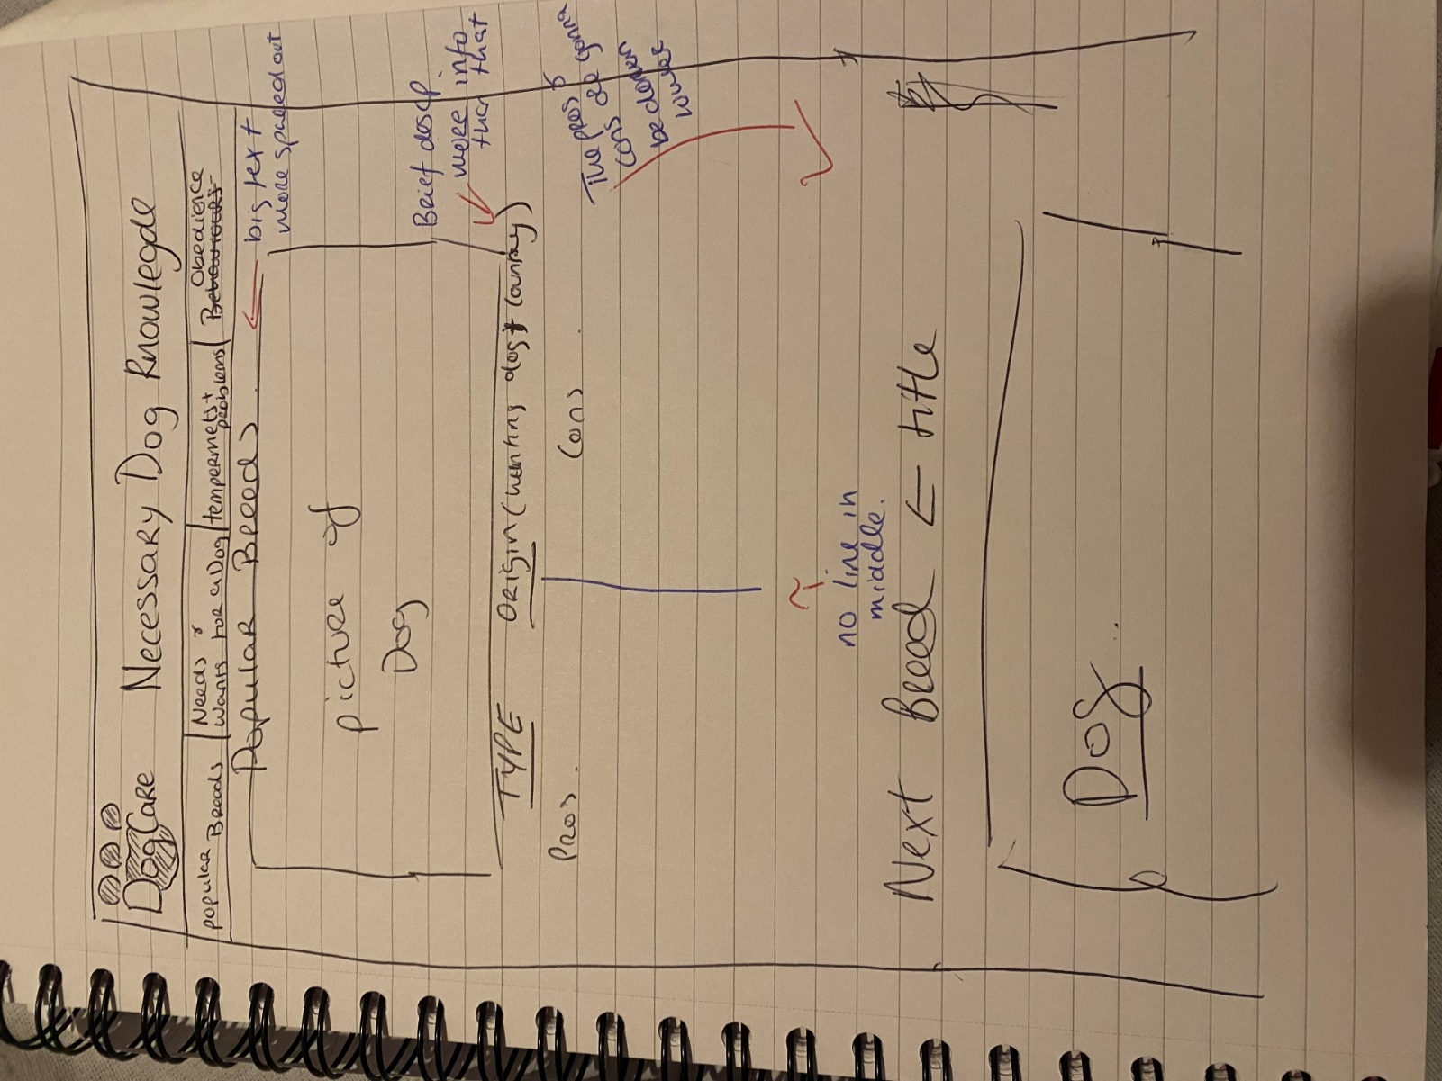

This was the original idea.

Declaration

I the undersigned declare that the project material, which I now submit, is my own work. This material or project has not previously been submitted for any other assignment. Any assistance received by way of borrowing from previous work, or the work of others has been cited and acknowledged within the work. I make this declaration in the knowledge that a breach of the rules pertaining to project submission may carry serious consequences. We are aware that the project will not be accepted unless this form has been handed in along with the project.

Website Topic: Dog adoption Site

Student name: Gemma Ryan

Student number: s00250864

Date: 14/04/24